API Review for DSA 8300 LV PnP

1. ACQUIRE:STATE  
   This command operates like the :STOP command which usually used in the Abort.vi, please support this command.
2. COMPENSATE  
   When reevaluate the command set, I saw the importance of supporting these command to customers. Would you please create 3 API to wrap-up these commands?

|  |
| --- |
| COMPENSATE:ALLMODULES  COMPENSATE:CH<X> |
| COMPENSATE:DARKLEV:{CH1|CH2|CH3|CH4|CH5|CH6|CH7|CH8} |
| COMPENSATE:OPTGAIN:{CH1|CH2|CH3|CH4|CH5|CH6|CH7|CH8} |
| COMPENSATE:RECALL:FACTORY:{CH1|CH2|CH3|CH4|CH5|CH6|CH7|CH8} |
| COMPENSATE:RECALL:FACTORY:ALLMODULES |
| COMPENSATE:RECALL:FACTORY:MAINFRAME |
| COMPENSATE:RECALL:USER:{CH1|CH2|CH3|CH4|CH5|CH6|CH7|CH8} |
| COMPENSATE:RECALL:USER:ALLMODULES |
| COMPENSATE:RECALL:USER:MAINFRAME |
| COMPENSATE:SAVE:USER:{CH1|CH2|CH3|CH4|CH5|CH6|CH7|CH8} |
| COMPENSATE:SAVE:USER:ALLMODULES |
| COMPENSATE:SAVE:USER:MAINFRAME |

1. ~~CURVE  
   The CURVE command is not implement in the IDDS. Which VI do you plan to add this command?~~

|  |
| --- |
| ~~DATA~~ |
| ~~DATA:DESTINATION~~ |
| ~~DATA:ENCDG~~ |
| ~~DATA:START~~ |
| ~~DATA:STOP~~ |
| ~~DATA:TIMEBASE~~ |

1. We shall probably support the DESKEW commands:

|  |
| --- |
| TDR:{CH1|CH2|CH3|CH4|CH5|CH6|CH7|CH8}:STEP:DESKEW |
| TDR:{CH1|CH2|CH3|CH4|CH5|CH6|CH7|CH8}:STEP:DESKEW:TIME |

1. General question: why the command mnemonic are all upper cases?
2. I think the below two commands can be combine to one ACQU:STOPAFTER:MODE {CONDITION|RUNSTOP}  
   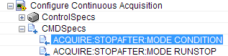
3. Configure Acquisition:  
   Configure Continuous Acquisition

Configure Continuous Acquisition Condition:  
Configure Continuous Acquisition Condition Action:  
a. I suggest you to regroup the ACQUire commands, here is my design:  
 i) All stop after command in one VI: **Configure Acquisition Stopafter**  
 ii) ACQuire:NUMAVg command in VI: **Configure Acquisition Average**  
 iii) Although we do not support MASK configuration, but we could support MASK acquire:  
ACQuire:CURRentcount:MASKHits<x>? Returns mask hits count  
ACQuire:CURRentcount:MASKSamples? Returns mask samples count  
ACQuire:CURRentcount:MASKTHits? Returns total mask hits count

ACQuire:CURRentcount:MASKUisamples? Returns number of acquired samples in the  
mask unit interval.  
ACQuire:CURRentcount:MASKWfms? Returns mask waveforms count

b. In the description, what do you mean by Run the Initialize VI or the Read Waveform Measurement VI before this VI?  
  
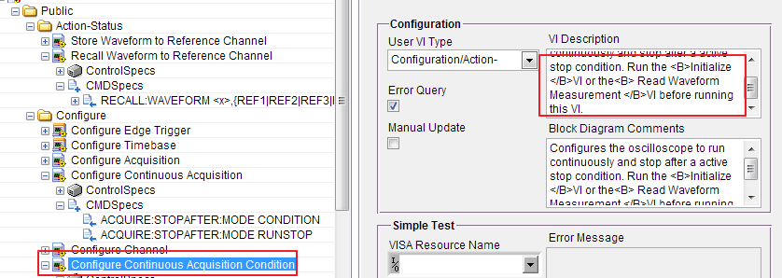

8. Change the enum name convention to Sample?   
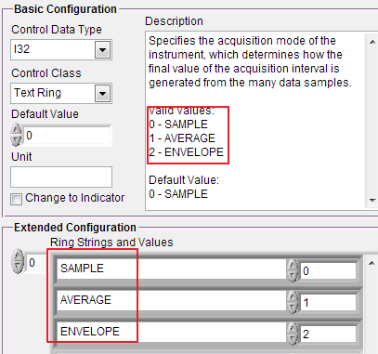

9. Read Mask:  
a. rename **Mask Polygon Number**, to Mask Name  
b. Use a meaningful name for ring control: e.g. Mask 1, Mask 2   
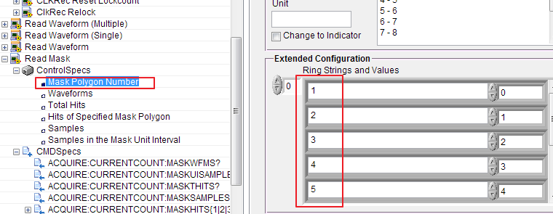

10. Configure Measurement (Relative).vi  
a. rename to “Configure Measurement (Reference)”  
b. Pl do not use short term in control names (Low Ref -> Low Reference)  
c. place Source to the top left position of the VI right after “Measurement Slot”  
d. rename “Second Mid Ref” to “Middle Reference Second”  
e. rename “High/Low Level Calculate Method” to “Calculation Method”  
f. please add unit in the left panel.  
g. I have some concern about merge Ref 1 and Ref 2 together. See the below red highlighted commands, I think user should be free to configure ref 1 or ref 2 to different MEAS slot. But in the current design, they cannot…  
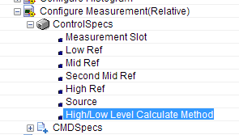  
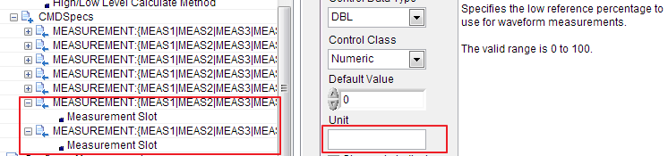

11. Configure Math, please adjust the parameter position, place Source 1 and Source 2 on top left.

12. Configure Edge Setting, I think all the MEASUREMENT: command could be design in APIs start with “Configure Measurement”, for this particular VI, rename it to “Configure Measurement (Edge)”

13. Configure Waveform Measurement Statistics  
Rename to Configure Measurement Statistics

14. TDR function:  
a. Rename “Configure TDR (Manual)” to “Configure TDR”  
b. To me, the preset TDR is more like an Action API, shall we move it to Action/Status folder and rename it to “Preset TDR” with a parameter select “diff/single”  
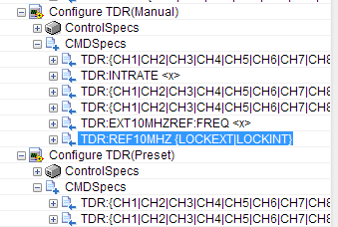

15. Clock Recovery  
a. Use “Clock Recovery” instead of CLKRec.  
b. I don’t think we need to implement “LOCKFp” commands   
c. We shall probably implement the following commands?   
 - “TRIGger:CLKRec:CRC:EDGEDensity?”  
 - TRIGger:CLKRec:CRC:LOCKCount?  
 - TRIGger:CLKRec:CRC:LOCKState?  
 - TRIGger:CLKRec:CRC:PHASEERRP2P?  
 - TRIGger:CLKRec:CRC:PHASEERRRMS?  
d. Rename “Configure CLKRec (Clock Output)” to “Configure Clock Recovery Output (Clock)”  
e. Rename “Configure CLKRec (Sub-rate Clock)” to “Configure Clock Recovery Output (Sub Clock)”  
f. Rename “Configure CLKRec (save Setting)” to “Save Load Clock Recovery Settings” and move to Utility\Clock Recovery group  
g. Rename “Configure CLKRec Standard (operation)” to two API “Query Clock Recovery Standard” and “Create Remove Clock Recovery Standard”   
h. Please remove the parenthesis in the following APIs:  
 - (Lock)  
 - (Phase Error Limit)  
 - (Equalizer)

16. In the Data\Low Level folder:  
a. Please move the following functions to utility.  
 - Clear Acquired Data  
 - Delete Waveform

- Clock Rec Reset Lockcount  
 - ClkRec Relock